 |  | BOOTH LAYOUT FORM  (EXAMPLE ON NEXT PAGE)  DEADLINE: September 12, 2025

Note: This form is required for placing machinery, electrical, plumbing or large-scale displays.

EMAIL COMPLETED LAYOUT TO D3PRODWI@GMAIL.COM BY 9/12/25

COMPANY NAME: |  | BOOTH#:
 | SCALE: 1 SQUARE =

IMPORTANT: Please indicate which way each piece of machinery faces using aisle numbers.

E
N S
W
AISLE ___ ___ ___ ___
AISLE ___ ___ ___ ___
WEST ENTRANCE (LOBBY)

EXHIBIT BOOTH PLAN LAYOUT

SAVE TIME & MONEY BY CAREFUL BOOTH PLANNING

EXHIBIT LAYOUT GRID

To help you plan your exhibit, lay out your exhibit to scale on the first page. Below is a sample showing what should be included on the grid. A copy of your layout should be sent to the proper contractors if you have any special requirements that will need pre-show attention. Be sure to include your exhibit number on the Grid and be sure to outline the perimeter of your exhibit in a heavy black line.

COMPANY NAME: | ABC Company | BOOTH#: | 1002
 | SCALE: 1 SQUARE = |  | 1 Foot

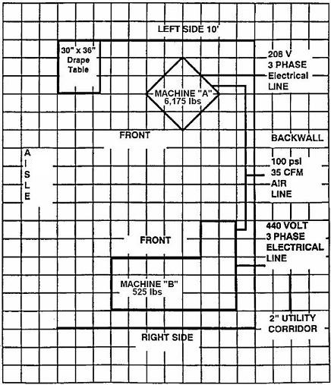

Items that should be considered when planning your exhibit:

1. Machinery positions & viewing areas for demonstrations.

2. Office/desk area & telephone location.
1400
AISLE
1500
3. Air lines.

4. Electrical lines.

5. Walk-thru traffic flow.

6. Type of floor covering, if any.

7. Mark aisle numbers.

8. Indicate direction
machinery will face.

